Backup and restore database
Backup database:
Two methods to backup the database:
1, Backup automatically
The software will back up the database itself when we log out the software.
The backup file will save in the file folder where you installed software.
Eg.: software is installed in Disk C, and we will see file folder “ AccessControl” will be generated. Under it , we will see file folder ”BACKUP”.
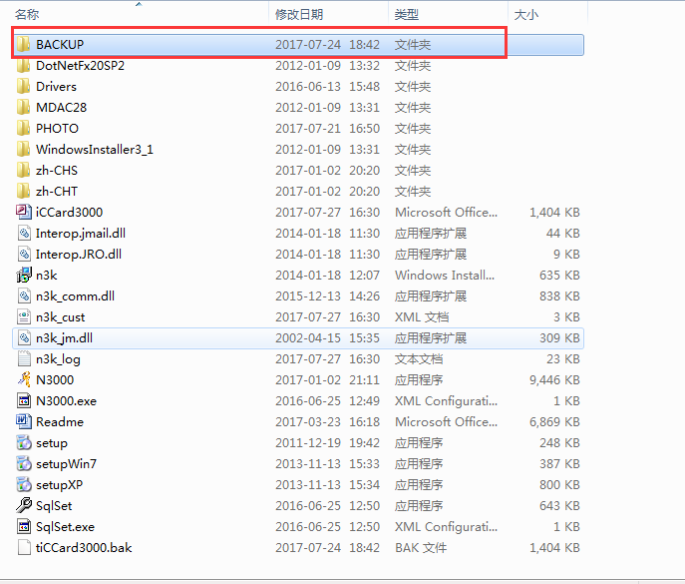
Click file folder “BACKUP”, you will see:
We log out software, you will a new backup file generated.
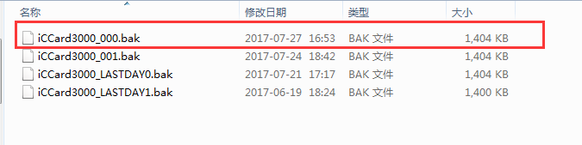

2, Back up manually
Click “File” DB Backup
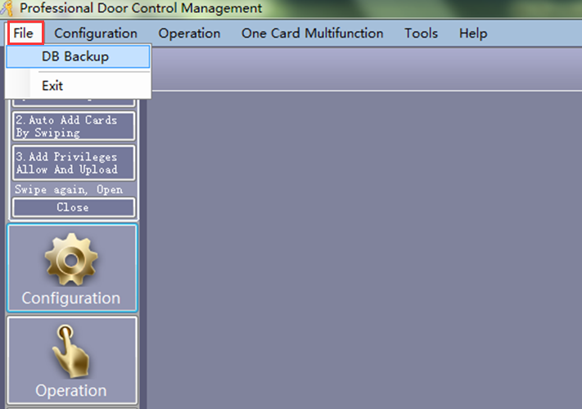
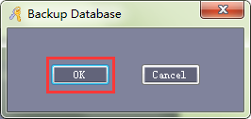
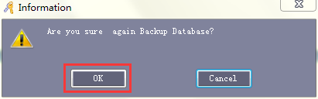
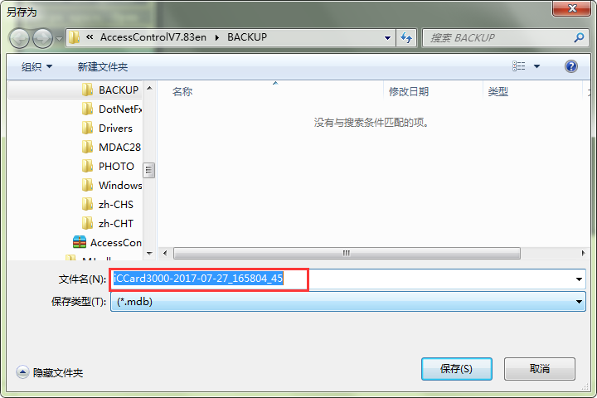
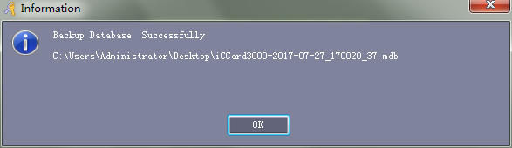
Choose the location you want save the Backup file. And then click “save”.
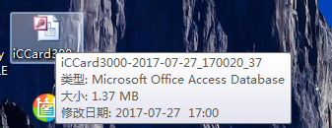
You will see the backup file in the file folder you saved it.

3, In the file folder of AccssControl, we will see this file
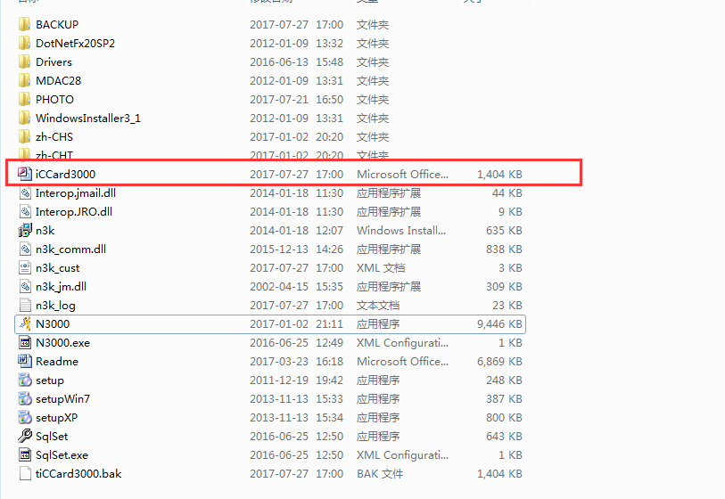
Just copy & paste this file to another Disk or other file folder you want. In this way, we also do the backup.

Now let’s talk about how to restore the backup file.
Just copy & paste our backup file to replace the file “ iCCard300”
1, In the file folder “ BACKUP”
Change its name to “ iCCard3000.mdb” and the copy this file and pate in the file folder “ AccessControl” and replace “iCCard3000” file.
We’ve done the restore backup.
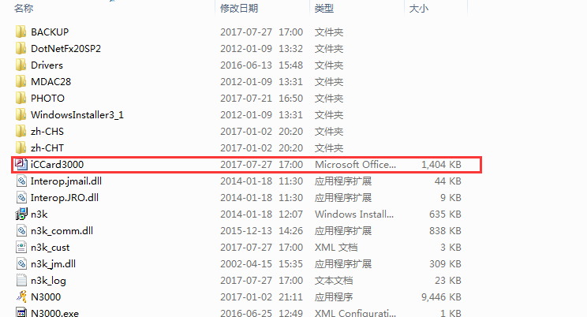

2, The same way, change the same name of backup file we manually saved. Copy and paste in “AccessControl” file folder.

3, Copy the file “iCCard3000” we stored in another Disk or file folder and paste in “AccessControl file folder.
We’ve done the restore backup file.

