Advanced setting for BC800NT
For our BC800NT controller and its software, all computers can connect to controllers as long as they are in the same LAN. For example, computer A, B, C all can connect to that controller, let's say this controller's SN: 422108888, and computer A, B ,C all can connect to it and add it to their software, then if computer A(person A), download the swipe record from controller on Mar. 2, and then he never logs in the software again until Mar 20, and on Mar 20, computer B (person B) want to check the record , so he download the record from controller, and he only can got the record from Mar. 3 to Mar. 20. And today Apr. 6, computer C (person C), want to check the record, so he download the record from controller, and he only can get recorder from Mar. 21 to Apr. 6

In this way, we will don’t have the full recorder in one computer, to solve this we have two way:
A, Just allow one or few computers can connect to the controller, 1 person in charge all those setting.

B, Set SQL server, use one computer as server with software and controller installed, other computers just use the software , then connect this server computer and can see all those setting and records.

A, Just allow one or few computers can connect to the controller.

1, Configurationcontrollerssearchselect the controller click right button of mousesee” IP filter” see a setting window pop up “set Comm Control IP List”If this is the first time you set this, then you should change the password in the windowfactory default password here is 654321 change to your new passwordinput allowed IP address, (you can add few, if you want) click button “change password and update IP list”.
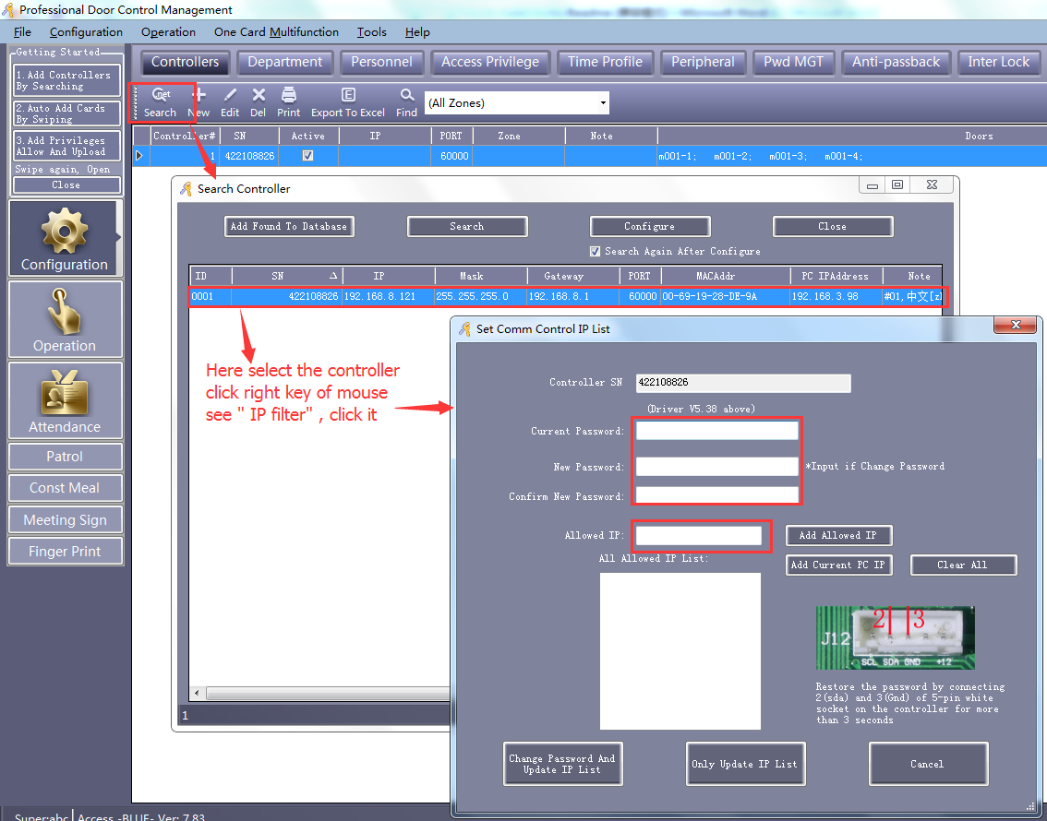

Here is menu of “click mouse right button”:
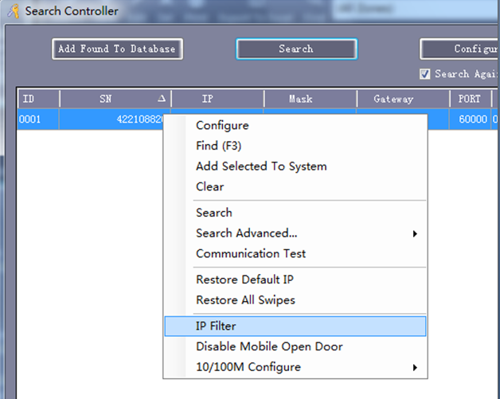
After we done these, only allowed computers can connect and see those swipe record of that controller’s.

B, Set SQL server, use one computer as server with software and controller installed, other computers just use the software , then connect this server computer and can see all those setting and records.

First: use a computer as a server (normally operator’s or person who in charge of it), install SQL ( 2000, 2005, 2008 all good), install software of BC800NT, connect the controller and add it in software.

Second:
1, After we install SQL, go to 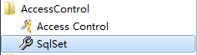 click “ SqlSet”

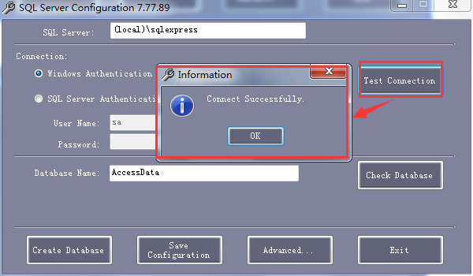

2, Click “Create Database”, you will see this :
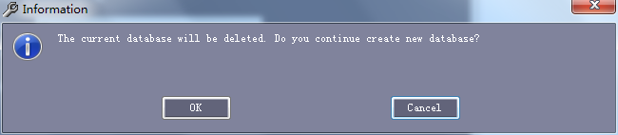

click “OK” then see this
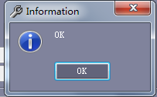
then OK Click Save Configuration then OK

3, log in software, you will see at the button of window of software, there shows SQL:

4, now we can add users, do all setting, upload to controller in the software in this server computer.

Thirdly : Share the SQL
Eg. computer A, B,C,D,E,F,G,H….
Computer A is server installed software and SQL and all those users and setting in the software.
The rest computer are client.
Now log in computer B, do this setting and connect to computer A
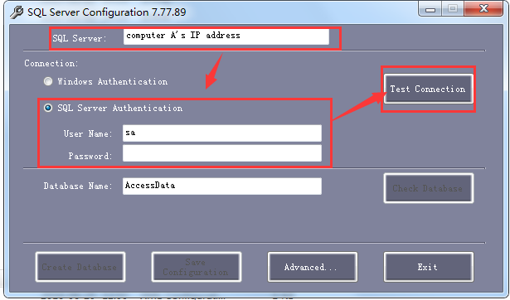
If show’s OK then we log in the software in computer B, we will see all those user’s, swipe record in computer A’s, now we can see all of them in computer B’s software.
It’s means SQL share is done.

We can do the same in the rest client computers.

P.S.: there is quick way to restore all swipes.
The best way is to appoint some managing software or do SQL share. So can keep all record in the software.
Pls see picture below:

