How to set Anti-Passback:
Make sure all your controllers connect to 1 switch board to make sure signal stable.
1, add the controller
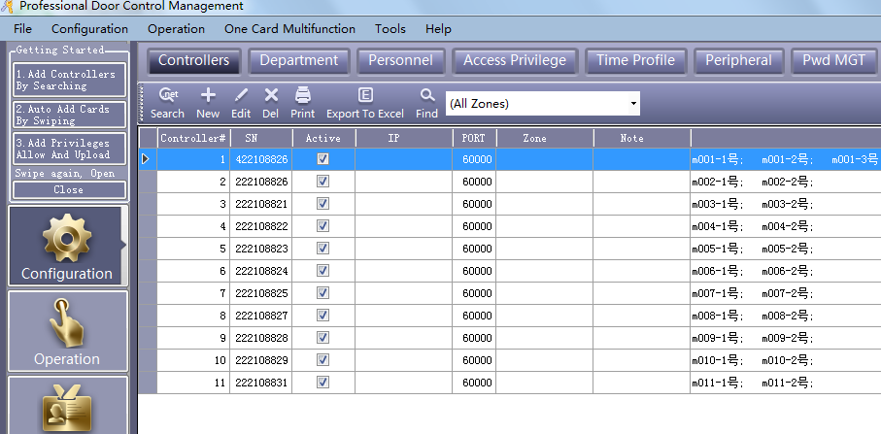

2, Click “anti-passback”
Press: ctrl+shift+Q
You will see: Active Anti-Passback Siganl sahre ( All Controllers in the same subnet)
Click this.
Then click the 10 pcs controller and click NO1 / NO2 each other.
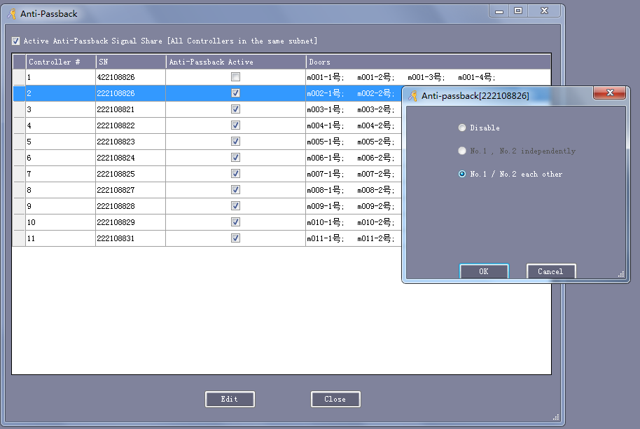

3, After you set all these 10 controller, then select these 10 controller’s door, then “upload”
