Overtime calculation(Overtime Rate)
1. Set the Normal Day==0.5; Set the Weekend== 1
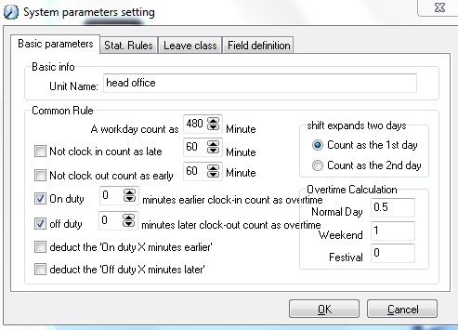

2. Arrange the timetable and shift. And arrange the shift to the employee.
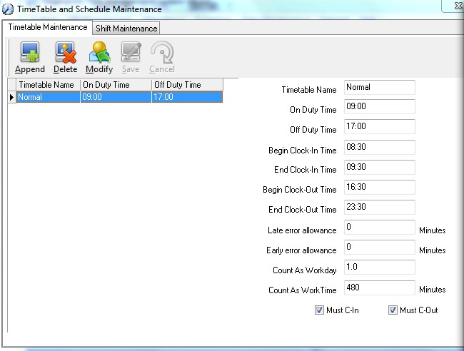
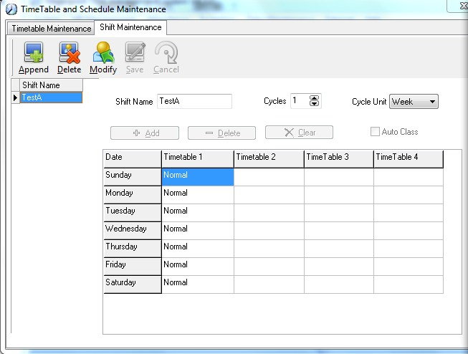
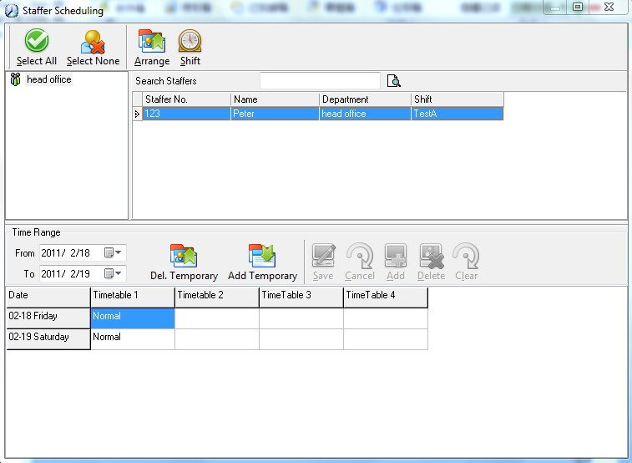

3. Check the records for employee "Peter" . Feb. 18, 2011 is Friday. Feb. 19, 2011 is Saturday.
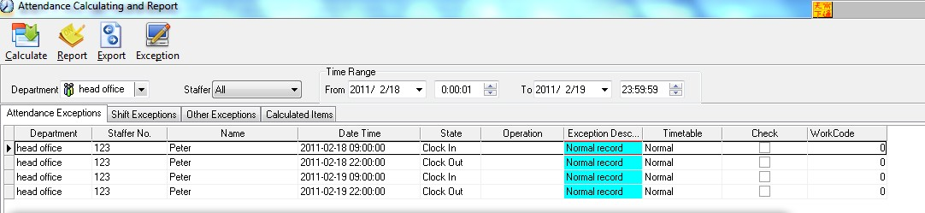

3. We can find that Peter have 5 hours(300minutes) overtime on both Friday and Saturday.
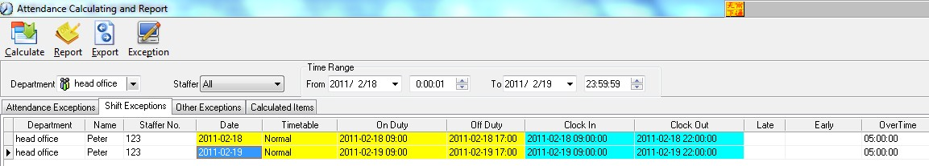

4. According to the settings in the "overtime calculation" in "system parameter settings", the Overtime on Friday is 0.5*realovertime and the overtime on Saturday is 1*real overtime.
So the normal day overtime is 150 minutes and the weekend overtime is 300 minutes finally. The total overtime is 450 minutes.
