How to add finger print to software, follow these steps:
First, we add user finger in device F007EM:
1, Do a excel file, record all user finger print ID and name in it. It’s suggested, because when there is someone left, we just delete its ID. Easy way and keep everything in record.
Employee name | Employee finger print ID
Operator | 1 | ID 1 is for manager add finger print. Normally this is for operator or owner who operates the device. So he use this finger print can add user
Operator | 2 | ID 2 is for manager delete finger print. Normally this is for operator or owner who operates the device. So he use this finger print can delete user
Abby | 3 | User ID start from ID3
Apple | 4
Ivy | 5
Cici | 6
… | …
… | …
… | …
… | …

2, entering programming mode and add user ID
*888888# press 1 3# Abby’s finger print, repeat Abby’s finger print 4# Apple’s finger print, repeat Apple’s finger print, 5#.........# at the end of it, we press # to confirm what we setting.

Second, we open software, go to add user information
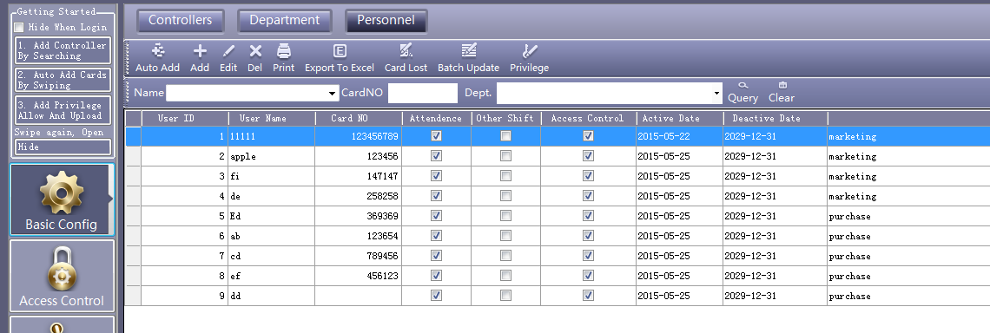
1, Click “ add’
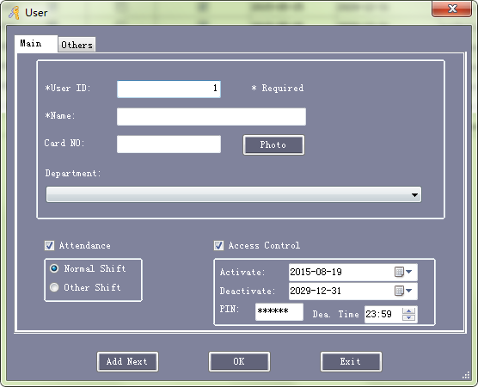
2, Here we add finger print ID no. in “ card No” and input user information accordingly.

3, After we finish all these user information input, we go access privilege setting.
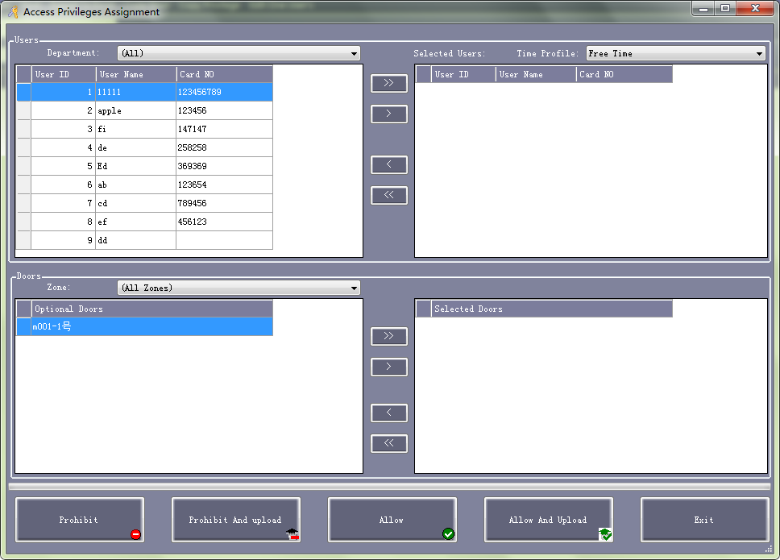

4 , After we’ve done all these setting. We go here, select the doors, and click “ upload”
