Sebury Technology Co., Limited
ADD: 5/F, Building 8, Xinwu Industrial Park, Xili, Nanshan District, Shenzhen,518055 China Tel: 755-82885461 Fax: 755-82884565
Http//:www.sebury.com.cn

RE: How to set fire alarm and alarm function.

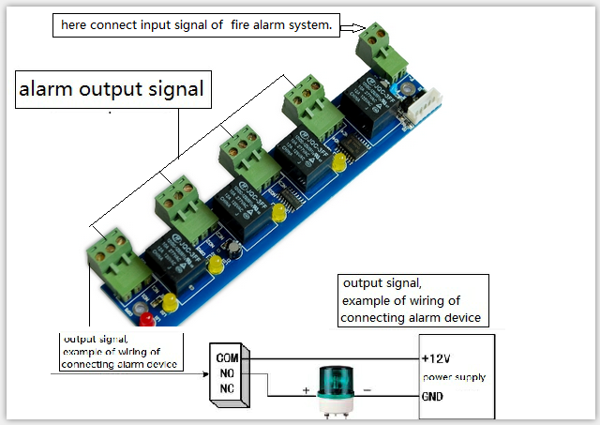

- After done all setting, we need select the doors and upload setting.

1,
Access software, click” tool” and click “ extended functions” , click “ Activate Peripheral control” and “ Threat code Valid After Register Card Swipe” . Then “ OK”.

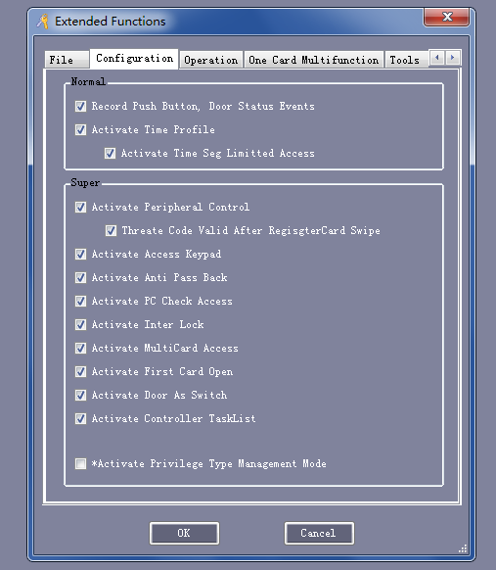

2, click “ configuration”, we will see “ Peripheral” , click “ Peripheral” you will this window.
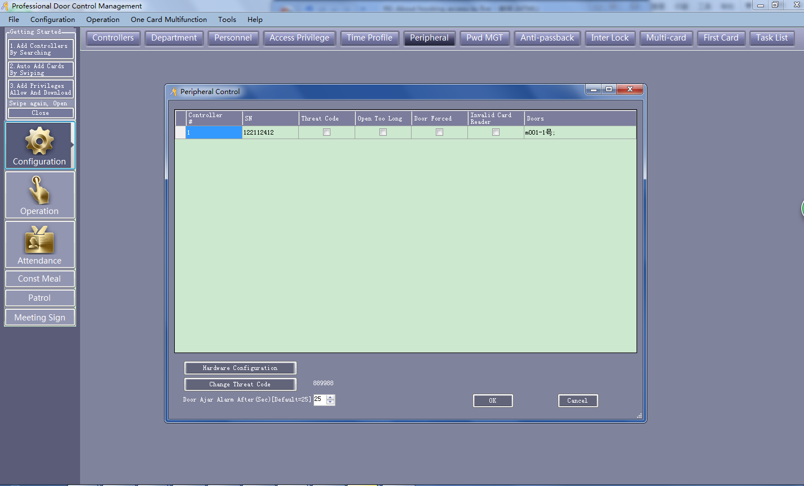

3, We click these boxes, then “OK”. We will see these alarm events showed in the log in software if happened.
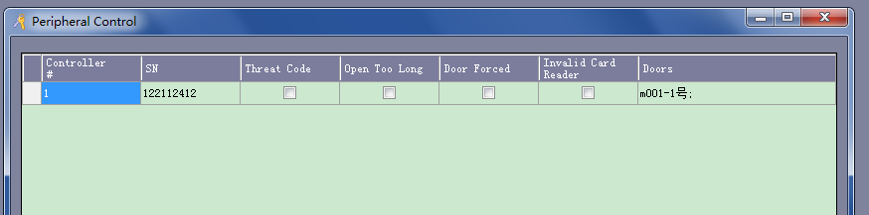

4, We click “ Hardware Configuration” , we will see this window. Here we can do the setting for alarm function.
Here Terminal block 1, 2,3,4 corresponding to relay on I/O board for output alarm signal.
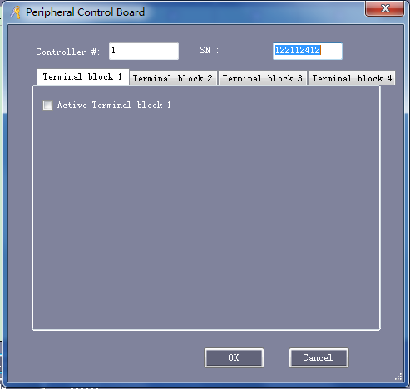
Click “ Terminal block 1” and “ Active Terminal block 1” , you will see this details and then you can do setting accordingly.
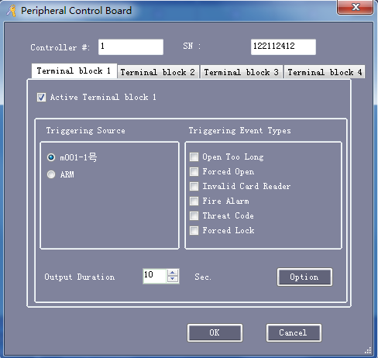

You also can click “ Option” and then you will see this, click these option as per your requirement.
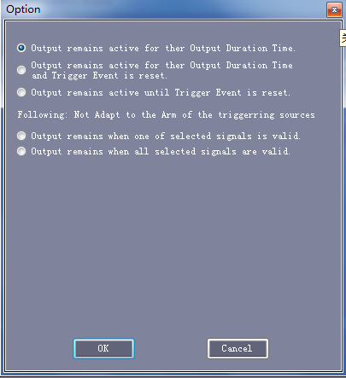
Below are detailed alarm function :
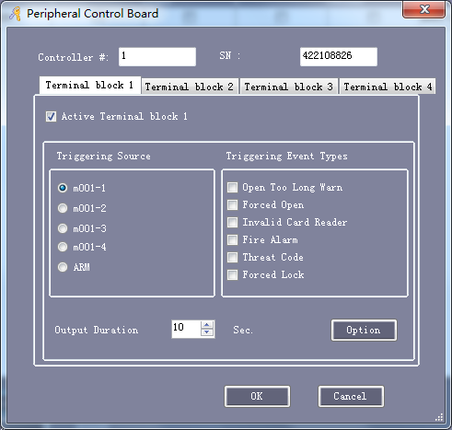
1, Door open too long, send alarm (software alarm and external alarm siren) ,
This alarm means we open door legal way (via card, fingerprint, exit button ), but not close in a certain minutes, there will be alarm.
First, door contact must connect to controller panel.
In the below picture, explain you these No. stands for:
1, Door ajar alarm after (sec), default 25 seconds: mean when we open door via legal way, and not close in 25 seconds, there will be alarm. This 25seconds you can change as per your preference.
2, Click “ Hardware configuration” , window “ Peripheral control board” pop out.
3,Here we “Active Terminal Block ” (means relay 1 of relay module )
4,Choose door and triggering event.
5,Output duration 10 seconds: mean relay working time when there is alarm. You can change this time as per your requirement.
6,Click “Option” , will see option window, here you can set these as per your want:
7,
1) output remains active for the output duration time: means door opened 25 seconds, relay will work 10seconds(means external alarm will siren 10seconds)
2) output remains active for the output duration time and trigger event is reset: means door opened 25 seconds, relay will work 10 seconds(external alarm siren 10seconds), even door is closed
3) output remains active until trigger event is reset : means door opened 25 seconds, relay will work 10 seconds, if in this 10second, door closed , then external alarm will stop.
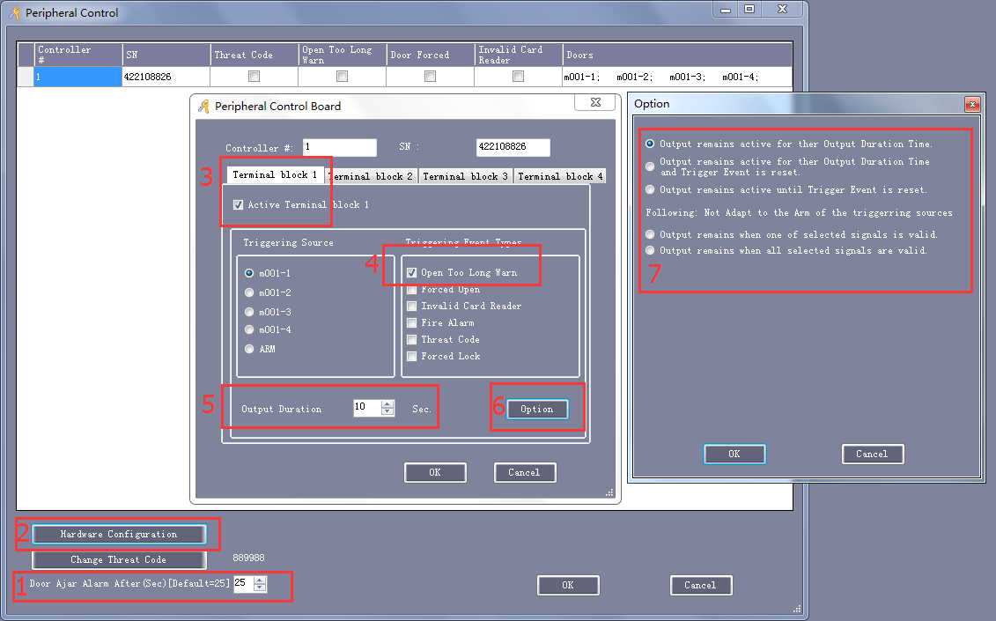

2, Door forced open, send alarm (software alarm and external alarm siren) ,
This alarm means door is opened via illegal way (not via card, fingerprint, exit button, break door contact to open door ), there will be alarm.
First, door contact must connect to controller panel.
You can choose and activate any block (relay) you want and click the triggering event” forced open)
Output duration time: you can change
Option: you can choose what you want(default is “output remains active for the output duration time)
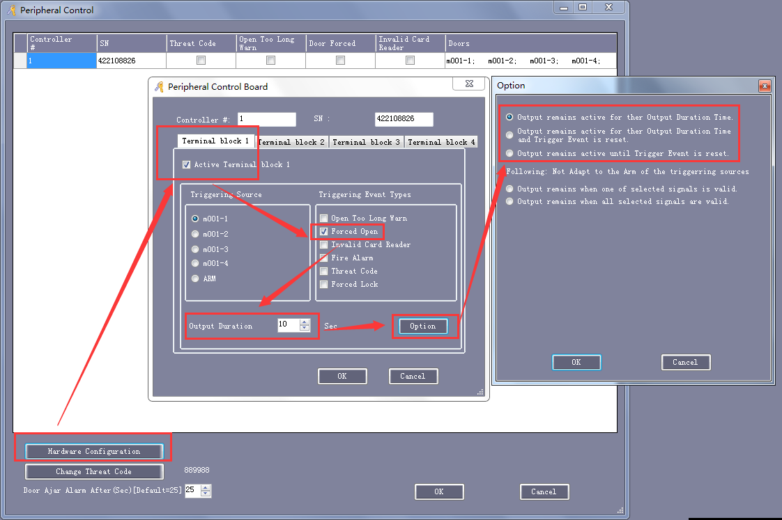

3, Invalid Card trigger alarm, send alarm (software alarm and external alarm siren) ,
This alarm means read invalid card, there will be alarm.
Output Duration time: you can change it.
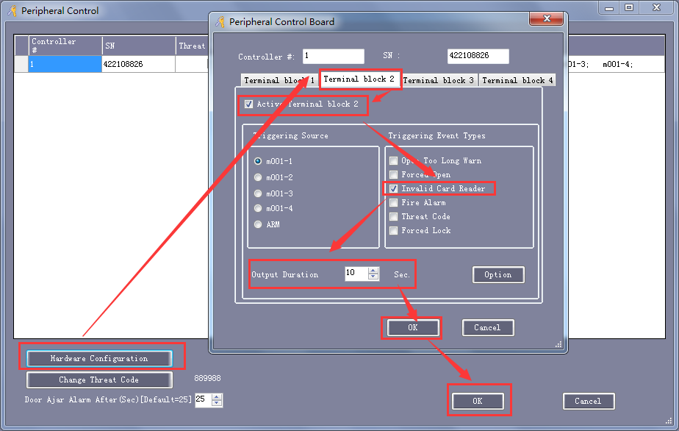

4,Forced lock door trigger alarm, send alarm (software alarm and external alarm siren) ,
This alarm means when suspicious people enter the space/ room, operator or people in control room press the button, doors will close automatically that the controller panel controlled. And there will be alarm.
We can pull two wire from this “ J9” on PCB board and connect to a press button. Once press this Button, doors controlled by this controller will close and send alarm. So peoople can capture the bad guy.
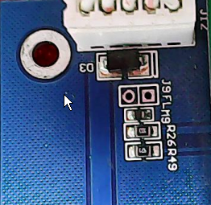
Output Duration time: you can change it.
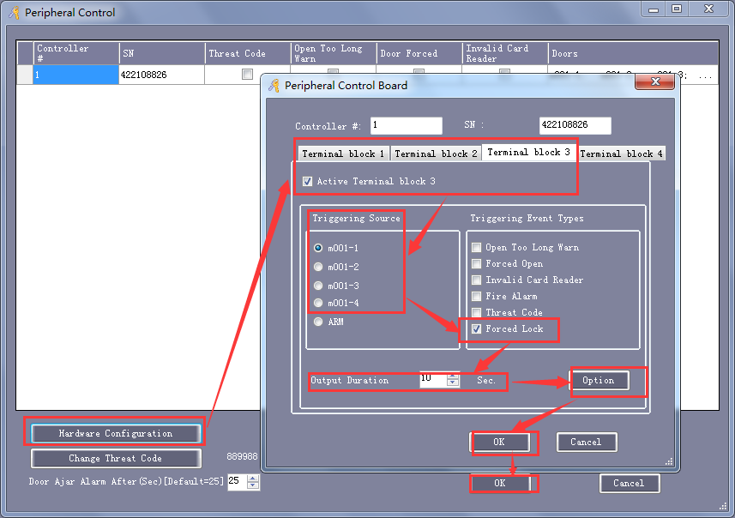

5, Fire alarm trigger alarm, send alarm (software alarm and external alarm siren) ,
This alarm means when fire & alarm module receive a closed fire alarm signal input, doors will open automatically that the controller controlled. And there will be alarm.

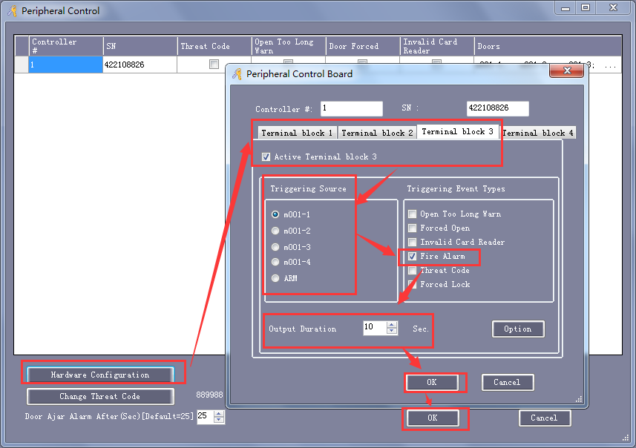

6, Threat code trigger alarm, send alarm (software alarm and external alarm siren) ,
This alarm means people in danger or under duress to open door; input this threat code will send alarm.
The Reader should be keypad reader.

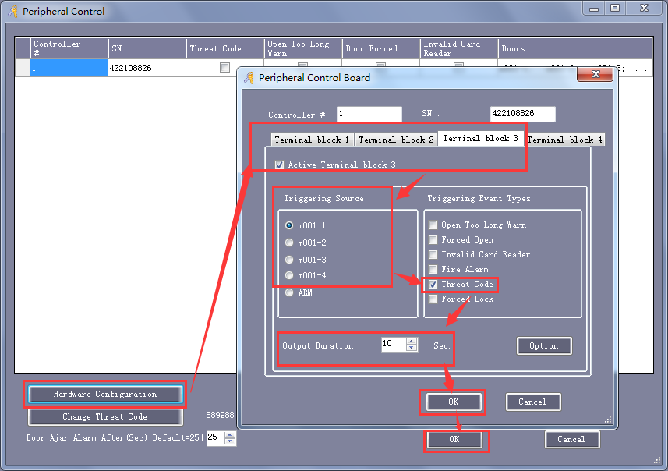
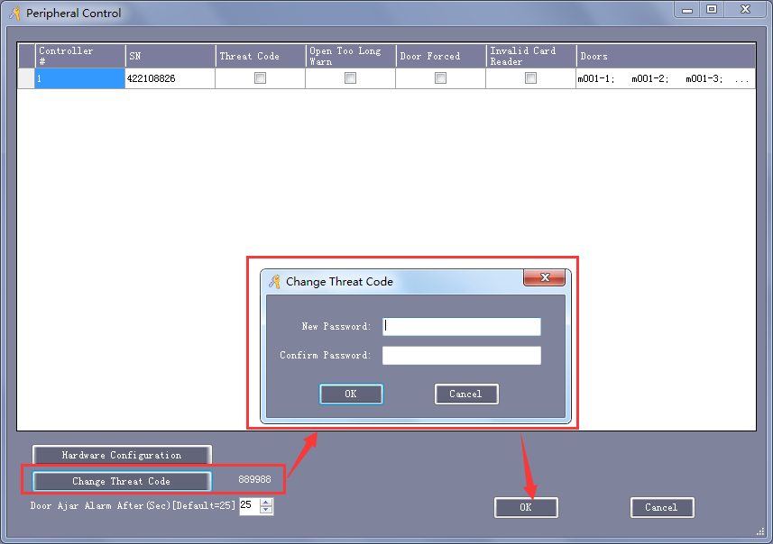
This default threat code is 889988.
You can change it.

7, Additional alarm function: If we choose this ”ARM” alarm pls see red square in below picture, send alarm (software alarm and external alarm siren) ,
This alarm means there is intruder alarm signal input, or smoke/gas/temperature alarm signal input or SOS signal input will send alarm.
In this case, you will need 4input/4output relay module shows below.
