How to set toggle mode in software:

1, toolextended function input password: 5678
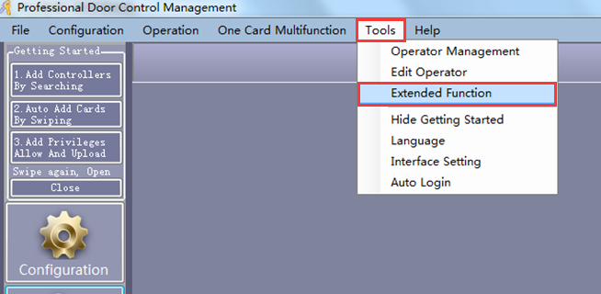
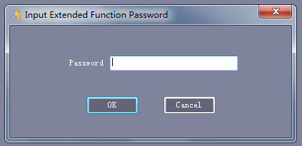

Click OK, will window pop up as below:

ConfigurationActivate Door as Switch
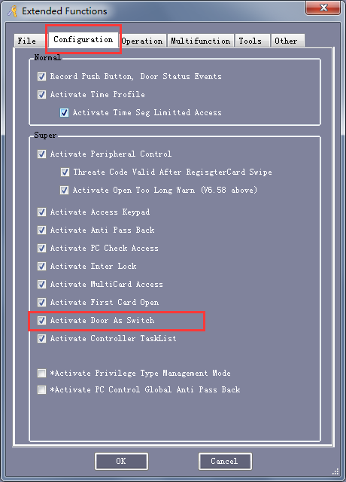

Then select the all of doors or some of doors you want this function and upload.

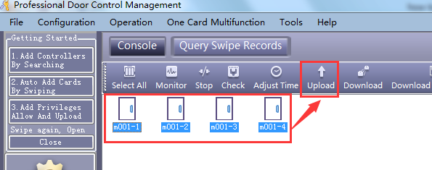

Toggle mode setting is done.
Then you swipe card on reader by the door, it will open, swipe again, it will close; swipe again, door open, swipe again, door close.

