Pls see picture. These are our task list. We can do the test via change the time of computer to verify it.

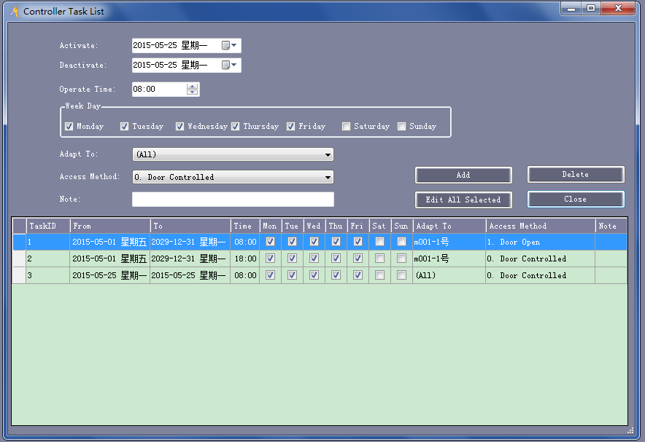

Here is how to verify the task list via change computer’s time.

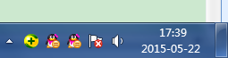 Button right corner of our computer, double click it.

1, first, we change its time to 7:58 am

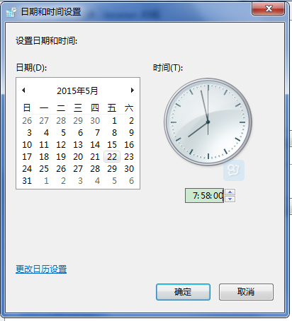 click “OK”

2,  We click “ Basic operate” , then select doors, and  click “ adjust time”

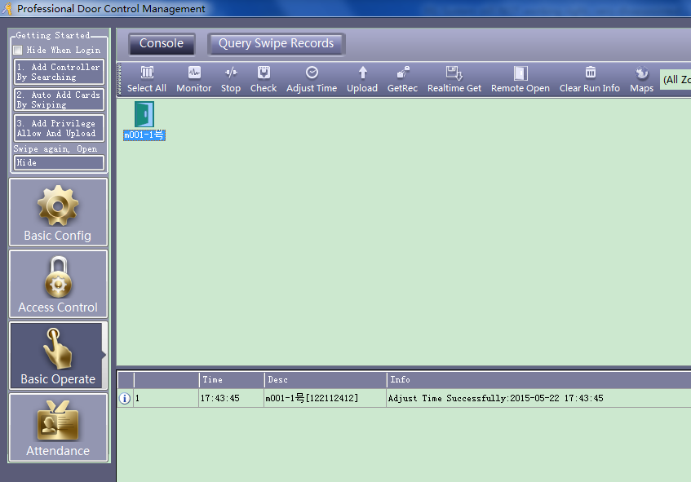we will see here shows we adjust time successful, means our software’s time is same as computer’s now.

Then we wait to 8am, the door will open. You can see it.

Same operation to verify door close on 18:00pm

1,  change computer’s time to 17:58pm

2, Same operation to verify door controlled on 18:00pm

click “ Basic operate” , then select doors, and  click “ adjust time” , software’s time will be the same as computer’s time. then we wait for 18:00pm, door will close.

Same operation to verify Memorial Day door controlled on 8:0am

1,  change computer’s time to 07:58am and date to 2015-5-25.

2, Same operation to verify door controlled on 8:00am

click “ Basic operate” , then select doors, and  click “ adjust time” , software’s time will be the same as computer’s time. then we wait for 08:00am, door will be controlled not open.